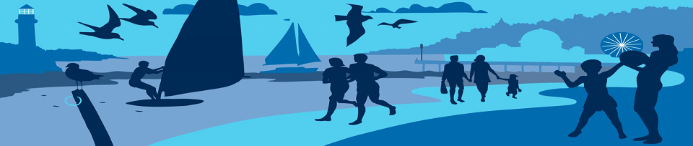

Solent Breezes: The current situation

This brief report has been produced as a summation of the process to date. It has been written on behalf of all the parties involved in the process, as requested at the community workshop on the 23rd January 2014, to help people identify their own route forward.

Progress to date
Part of the EU funded Coastal Communities 2150 project, led by the Environment Agency
Local delivery is via the CCATCH project, run by Hampshire County Council which has the following purpose. “CCATCH ‐ the Solent’ will raise awareness and understanding amongst five Solent communities of coastal change and in particular sea level rise. It will help communities understand the process of coastal change to enable adaptation and increase resilience.”

A meeting held in April 2013 agreed the following aims & objectives for CCATCH @ Solent Breezes:

Aim: The whole community of Solent Breezes to be aware of implications of coastal change and be able to manage adaptation as the shoreline erodes.

Objectives
- To raise awareness of the current risks to different sectors of the community.
- To help the community understand the future options available to them in respect to protecting their properties from coastal erosion
- To explore the financial, legal and practical implications of those options to help identify a preferred option(s) and the actions required for implementation.
- To encourage partnership working among landowners.

A subsequent meeting held in July 2013 agreed to adopt a ‘joint fact finding’ approach to exploring the future options for the community. The CCATCH project hired a consultant to firstly undertake a conditions assessment of the existing sea defences and then to work with the community to research and develop options for their consideration.
A brief for the retained consultant was agreed with the community and a resulting report was discussed at a workshop held in November 2013.

A final workshop was held in January 2014 with the intention of agreeing the first steps in a more cooperative approach to the defence of the coastline at Solent Breezes.

The CCATCH project only runs until the end of February 2014 so any further discussions need to be initiated by the different landowning interests on the site. This summary report sets out the situation at the end of the CCATCH project.

Current approach to coastal defence
- Nine Chalet owners invest in coastal defence in front of their own properties and have a small working pot of money for maintenance and eventual replacement.
- Park Holidays spends significant funds (which they have offered to quantify) on maintaining the defences in front of their landownership and other parts of the site.
- No other owners contribute to defences (these include the other chalet owners, Hampshire County Council).
- Both the CCATCH project and Park Holidays have commissioned studies and estimates of proposed works on current and future coastal defence options and both are prepared to make these available to aid future discussion.
Rights & Responsibility
- All land owners retain their rights & responsibilities as owners of land and property.
- The current circumstances place the responsibility for maintaining the defences in a safe condition on the person or persons who constructed the current features. That responsibility is taken on by any one doing any new works.
- Therefore the decision to invest remains the prerogative of the individual owners, accept where there is a requirement, identified by the Borough Council to undertake work on safety grounds.
- This means any investment in coastal defence should be voluntary (accept where legal responsibility dictates otherwise) unless all of the property owner’s sign up to some form of funding mechanism such as requiring their property to pay a set and ongoing fee towards the maintenance of sea defences.
Three possible future options for the management of coastal defences at Solent Breezes
- Individual responsibility, coordinated action: Different people take responsibility for the defence of different sections of coast with an underlying plan that's followed by all. This would require co-ordination to ensure works take place in a compatible way and compatible timings. This therefore also needs funding to be available from all involved when required.
- One landowning group (Chalet owners or Park Holidays) take responsibility for the defence of the coast. A restricted (only to be spent on coastal defence) fund is then set up to which other parties contribute and some form of legal agreement is made regarding ongoing duty to maintain the defences in a safe condition.
- Set up a new independent body for management (and responsibility) of the coastal defences. This would need a sustainable income such as money invested in by chalet owners/ company/ others. It could also generate fundraising activities and direct commercial income (e.g. letting moorings/ landing fee). Such a body would also need some form of legal arrangement to cover the ongoing duty of care which all the landowners involved would have to be party to.
Insurance & external financial support
- Coastal Erosion is not an insurable risk.
- The only government provided financial support to property owners is a payment of a maximum of £6000 to help with the demolition and removal of properties that are in danger of collapse
Possible next steps
There is not complete agreement yet on the best approach to joint working but the emerging first step seems to be;
- Chalet owners establish a representative body and communication system for working with the company and other interested parties
- The company & chalet owners establish regular meetings.
- Chalet owners to start a working fund, supported by voluntary contributions based on a scale related to distance from the coast.
- The company and the chalet owners work towards agreeing an approach to maintaining coastal defence
The conversation about coastal defence has not always been easy as there are many competing interests and some historical animosity between various parties. It is hoped that the CCATCH engagement process has made a start in improving the relationship between parties and identifying common ground. If we have learnt two things they are:
- coastal defences affect all the properties to varying degrees and as such are not the responsibility of any one landowner, large or small
- the importance of keeping the conversation going and focussed on future options rather than past problems.

Mike King
Steve Evison
February 2014

